~ With Sincere Sympathy ~

Dr. David C. Petreccia
December 11, 1954 – September 12, 2014
Medical Staff for 28 years
Medicine Department – Infectious Disease
Viewings
Thursday, September 18th and
Friday, September 19th 4:00 pm – 7:00 pm
Chapman Mortuary in Orange
1342 E Chapman Ave, Orange, CA 92866
Funeral Mass
Saturday, September 20: 11:00 A.M.
St. Martin de Porres Catholic Church
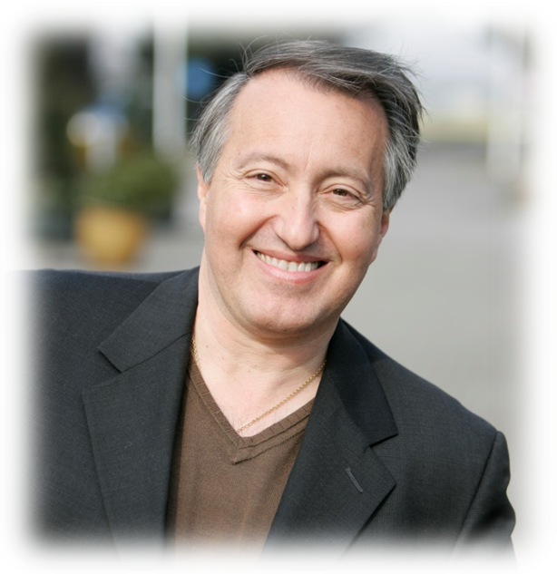
19767 Yorba Linda Blvd, Yorba Linda, CA 92886

Reception:
Saturday, Sept 20 from 2:00 – 4:30
Placentia-Linda Hospital
Meeting Rooms #1 and #2
1301 N. Rose Drive
Placentia, CA 92870
(Enter MR #2 from main walkway)

Cross Streets – Yorba Linda Blvd./Rose Drive – Main entrance on Right just past Yorba Linda Blvd.

