Date: October 5, 2015

To: INVITATION TO ALL ST. JUDE MEDICAL STAFF PHYSICIANS

Re: Annual Medical Staff Meeting – November 2nd

Please join us for the Annual Medical Staff Meeting. We are happy to announce the following keynote speaker:
Dave Logan
NY Times bestselling author and cofounder of CultureSync, a management consulting firm specializing in cultural change, strategy and negotiation, Logan is the author of #1 Bestseller Tribal Leadership: Leveraging Natural Groups to Build a Thriving Organization and the Three Laws of Performance: Rewriting the Culture of Your Organization and Your Life.

We encourage you to visit the following link to view Dave Logan’s Ted Talk at: https://youtu.be/xTkKSJSqU-I

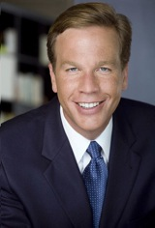

Date: Monday, November 2nd

Time: 5:30 pm – Tours Available
6:00 pm Cocktails/Appetizer with Dinner to Follow

Place: Nixon Presidential Library – East Room

Please contact the Medical Staff Office to confirm your attendance at the following:
Phone: 714-446-5751 Email: sjfphysicians@stjoe.org

POINTS AWARDED TOWARD STAFF STATUS FOR ATTENDANCE AT THIS MEETING

