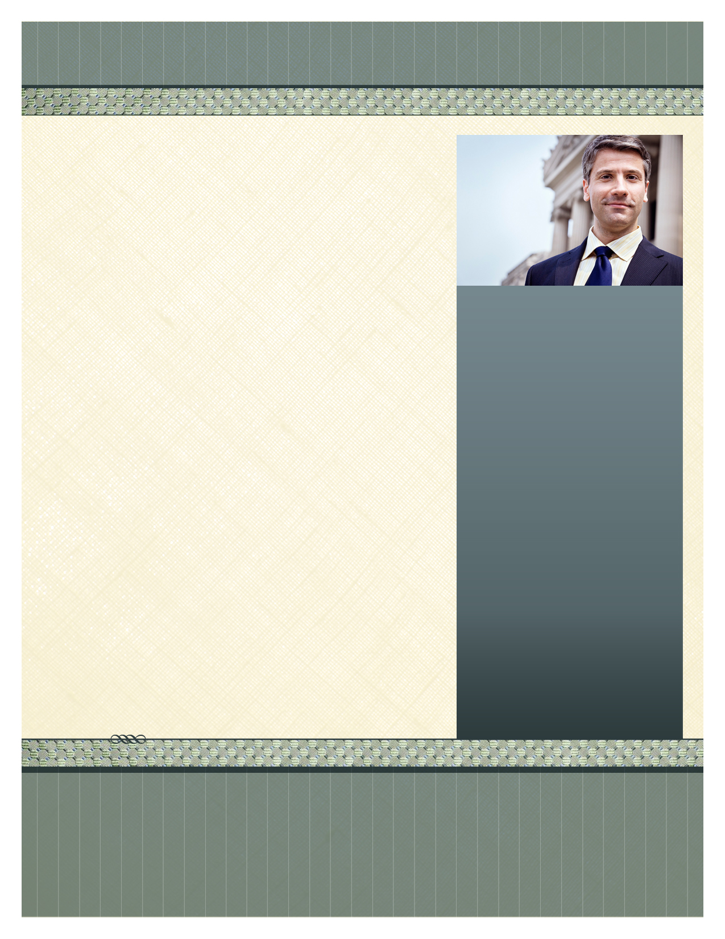

­

***Limited Seating - Please RSVP prior to April 25th to confirm seating***

***Call: 714-446-5751*** *or* ***Email to: sjfphysicians@stjoe.org***

Don’t forget all attendees will be awarded points toward your Senior Active, Active, Courtesy Staff Status.

**Keynote Speaker: Jay Kaplan, M.D.**

Medical Director, Studer Group & Director of Service & Operational Excellence, CEP America Emergency Physician Partners

**Topic: *Beyond Patient Satisfaction: How to Astonish your Patients***

Most physicians went into medicine in order to help people. To our patients, quality and service are inseparable. Many studies show that physician communication correlates with patient compliance to treatment regimens and hence with clinical outcomes. While our intent is always to give our patients the best care, that is not always their perception. This session will focus on why service excellence is important and what specific skills physicians can demonstrate to astonish our patients.

Date: Tuesday, April 29th

Time: 6:00 pm

Place: St. Jude Medical Center

Erickson Educational Center – 3rd Floor

Registration on 2nd Floor

**St. Jude Medical Center Medical Staff**

**You are Cordially Invited to Attend**

**The General Staff Meeting**

*Dr. Kaplan is a graduate of Harvard College and Harvard Medical School. Not only has he won teaching awards in 1996 and 1999, but in October 2003, he was named the American College of Emergency Physicians’ Outstanding Speaker of the Year. As a national speaker and facilitator, Dr. Kaplan makes presentations to hospital leadership teams, emergency departments, medical groups and physicians as well as, conducting various coaching sessions; always maintaining the highest standards of clinical quality and service excellence. While he enjoys being an educator, Dr. Kaplan continues to practice medicine because of his love of the clinical aspect of medicine. In addition, caring for his patients helps him remain close to them as well as their families, the hospital staff and his colleagues.*

**Menu:**

* **Roasted Vegetable Salad, Assorted Seasonal Fruit, Assorted Dark & Semi-Sweet Chocolates**
* **Assorted Cheeses & Hummus w/Pesto Spread**
* **Tandoori Chicken Breast w/Coconut Saffron Israelli Cous Cous, Confetti Wild Rice Pilaf, Mushroom Duxelle w/Cognac Cream Thai Spicy, Peanut Noodle Salad , Roasted Vegetable Salad, Seafood Tower (Shrimp & Snow Crab Claws), Salmon En Croute, Roast Beef Carving Station**

**Cocktails: Red & White Sangria, Assorted Wines and Assorted Beers**

**Deserts: Citrus Mousse W/Raspberry Coulis, Pecan Crunch Rum Bars, Tiramisu Cups, Fresh Fruit Tarts**

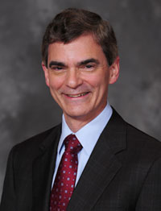

Insert Your Name Here

Place logo

or logotype here,

otherwise

delete this.

555 Street Address, Suite 555

City, STATE 97555

555.555.5555 **office** • 555.555.5555 **fax**

[www.your-url-goes-here.com](http://www.your-url-goes-here.com)